Module (Bootstrap Basic & Advanced) – 6

1. What are the advantages of Bootstrap?Bootstrap is a web development framework that has several advantages123:

Fewer cross-browser bugs

 A consistent framework that supports major of all browsers and CSS compatibility fixes

Lightweight and customizable

Responsive structures and styles

Several JavaScript plugins using the jQuery

Good documentation and community support

Loads of free and professional templates, WordPress themes and plugins

Great grid system

Easy to use

Facilitates users to develop a responsive website

Compatible on most of browsers like Chrome, Firefox, Internet Explorer, Safari and Opera etc.

Mobile-first approach: In Bootstrap 3, mobile-first styles are part of the core framework



1. What is a Bootstrap Container, and how does it work?

**Ans**. Bootstrap Containers are the most basic layout element in Bootstrap. Bootstrap Containers are very essential and basic building blocks of bootstrap that wrap a page’s content. It’s responsible for setting and aligning content within it according to viewport or given device. Containers are defined within the container class (.container). In other words, we can say that containers are established the width for the layout to give the content. Elements and content are added within the container.

**Containers are used for many purposes such as –**

• It requires use with the default grid system.

• To establish width for the layout to give web content.

• To provide responsive fixed behavior of any web project.

• To sets the content margin dealing with the responsive behavior of your layout.

Basically, there are three types of container classes available in bootstrap:

1. Default-Container(container)

2. Responsive-Container(along with sm, md, lg, xl, xxl)

3. Fluid-Container(container-fluid)

**1. Default-Container:**

The default container uses ‘.container’ class. It provides a responsive fixed-width container.

Syntax:

<div class="container">

<!-- Content here -->

</div>

**2.Responsive-Container**:

Responsive containers are responsive in nature. Responsive containers allow you to specify a class that is wide until the specified breakpoint is reached, after which we apply max-widths for each of the higher breakpoints.

Syntax:

<div class="container-sm">Wide for small breakpoint</div>

<div class="container-md">Wide for medium breakpoint</div>

<div class="container-lg">Wide for large breakpoint</div>

<div class="container-xl">Wide for extra large breakpoint</div>

<div class="container-xxl">Wide for extra large breakpoint</div>

1. **Fluid-Container:**

Fluid-container uses the ‘.container-fluid’ class. It is used for a full-width container, spanning the entire width of the viewport.

Syntax:

<div class="fluid-container">

<!-- Content here -->

</div>

**3.What are the default Bootstrap text settings?**  **Bootstrap 4 Default Settings**

Bootstrap 4 uses a default font-size of 16px, and its line-height is 1.5. The default font-family is "Helvetica Neue", Helvetica, Arial, sans-serif. In addition, all <p> elements have margin-top: 0 and margin-bottom: 1rem (16px by default).

**4.What do you know about the Bootstrap Grid System?**

**Ans. Bootstrap Grid System**

1. Introduction and Installation

2. Buttons, Glyphicons, Tables

3. Vertical Forms, Horizontal Forms, Inline Forms

4. DropDowns and Responsive Tabs

5. Progress Bar and Jumbotron

**Prerequisites:** Web Development Basics and BootStrap (Part-1)

**Grid System:** In the previous article we had learnt about Bootstrap and its Installation.However, from this article, we are going to start with learning Bootstrap. We are going to talk about the Bootstrap Grid System in this article.

**Grid System:** Bootstrap Grid System allows up to 12 columns across the page. You can use each of them individually or merge them together for wider columns. You can use all combinations of values summing up to 12. You can use 12 columns each of width 1, or use 4 columns each of width 3 or any other combination.

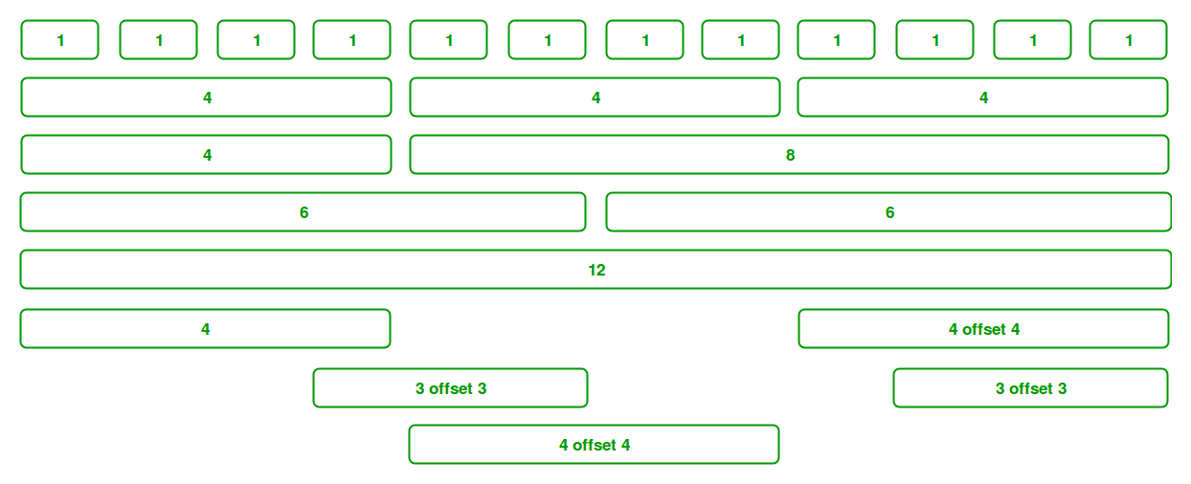

**Grid Classes:** The Bootstrap grid system has four classes that can be combined to make more flexible layouts:

xs (<576px): For Portrait Mobile Phones.

sm (>=576px): For Landscapes phones

md (>=768px): For Tablets/Phablets

lg (>=992px): For Small-sized Desktops/Laptops

xl (>=1200px): For Larger-sized Desktops/Laptops

Note: Output can be little difference as shown, it depend on your screen size.

Components of Grid System: We will be learning the Components of the Grid system one-by-one:

**1.Containers:** Bootstrap requires a containing element to wrap site contents and house our grid system. The word ‘container’ is a container of row elements and row elements are ‘containers’ of the column elements. You will understand it more in the latter part of the article where we have dealt with columns.

Use ‘container’ for a responsive fixed width container and use ‘container-fluid’ for a full width container, spanning the entire width of your viewport.

Example:

<!DOCTYPE html>

<html lang="en">

<head>

<title>Bootstrap Example</title>

<meta charset="utf-8">

<meta name="viewport"

content="width=device-width, initial-scale=1">

<link rel="stylesheet" href=

"https://maxcdn.bootstrapcdn.com/bootstrap/4.3.1/css/bootstrap.min.css">

<script src=

"https://ajax.googleapis.com/ajax/libs/jquery/3.4.0/jquery.min.js">

</script>

<script src=

"https://cdnjs.cloudflare.com/ajax/libs/popper.js/1.14.7/umd/popper.min.js">

</script>

<script src=

"https://maxcdn.bootstrapcdn.com/bootstrap/4.3.1/js/bootstrap.min.js">

</script>

</head>

<body>

<header>

<div class="container">

<h1 style="color: green">GeeksforGeeks</h1>

<strong>

A computer Science portal for Geeks

</strong>

</div>

</header>

<div class="container">

<div class="row">

<div class="bg bg-primary w-100">

First row

</div>

</div>

<div class="row">

<div class="bg bg-success w-100">

Second row

</div>

</div>

<div class="row">

<div class="bg bg-primary w-100">

Third row

</div>

</div>

<div class="row">

<div class="bg bg-success w-100">

Fourth row

</div>

</div>

<div class="row">

<div class="bg bg-primary w-100">

Fifth row

</div>

</div>

</div>

<footer>

<hr />

<div class="container">

<p>

<a href="https://www.geeksforgeeks.org/">

Visit

</a>

our website

</p>

<p>

<a href="https://www.geeksforgeeks.org/">

Like

</a>

us on facebook

</p>

</div>

</footer>

</body>

</html>

**Outpot:**

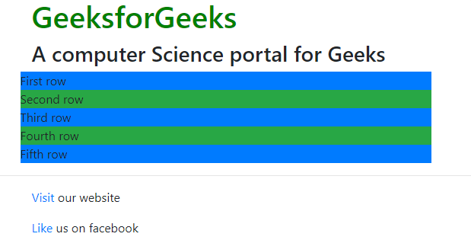

1. **What is the difference between Bootstrap 4 and Bootstrap 5**

**Difference between Bootstrap 4 and Bootstrap 5**

|  |  |  |
| --- | --- | --- |
| **BASIS OF** | **BOOTSTRAP 4** | **BOOTSTRAP 5** |
| **Grid System** | It has 5 tier (xs, sm, md, lg, xl). | It has 6 tier (xs, sm, md, lg, xl, xxl). |
| **Color** | It has limited colors. | Extra colors added with the looks, A card improved color palette. there are various shades available to choose. |
| **Jquery** | It has jquery and all related plugins. | Jquery is removed and switched to vanilla JS with some working plugins |
| **Internet Explorer** | Bootstrap 4 supports both IE 10 and 11. | Bootstrap 5 doesn’t support IE 10 and 11. |
| **Form elements** | Radio buttons, checkboxes have different look in different OS and browsers. The form uses whatever default browsers provide. | The look of form elements will not change, on different OS or browser. The forms can be customized and form controls can be added, they would not depend on browser. |
| **Utilities API** | We cannot modify utilities in bootstrap 4 | Bootstrap 5 gave freedom to modify and also create our own utility |
| **Gutter** | We use .glutter with fontsize in px | We use .g* with fontsize in rem |
| **Vertical Classes** | Columns can be positioned relative | Columns cannot be positioned relative |
| **Bootstrap Icons** | Bootstrap 4 doesn’t have its own SVG icons, we have to use font-awesome for icons. | Bootstrap 5 have its own SVG icons |
| **Jumbotron** | It supports. | It doesn’t support jumbotron. |
| **Card deck** | The card deck is used to create a set of cards with equal width and height. | Card deck class in removed in bootstrap |
| **Navbar** | We have inline-block property and we will get white dropdown as default for dropdown-menu-dark class. | Inline-block property is removed and we will get black dropdown as default for dropdown-menu-dark class. |
| **Static Site Generator** | Bootstrap 4 uses Jekyll software. | Bootstrap 5 uses Hugo software as it is fast static site generator. |
| **flexbox grid** | this makes easier to implement vertical designs, and the columns and rows can easily be implemented. the classes justify-center-content can directly be used to align according to the requirement. | advanced grid system is made available , also columns don’t have relative positions. |
| **RTL Support** | It does not enable RTL(Right to Left) switching. | It enables RTL(Right to Left) switching. |

1. **What is a Button Group, and what is the class for a basic Button Group?**

“Button Groups” in Bootstrap is a class of name “btn-group” which is used to create series of buttons in groups (without spaces) vertically or horizontally.

This is the basic syntax of the button group class where each button has its own class of “btn”.

<div class="btn-group">

<button type="button" class="btn">Click</button>

</div>

Buttons have a default border-radius on the first and last buttons of the group.

Adding Styles on Buttons: Bootstrap allows you to add styles to your buttons using the following classes:

• .btn-default

• .btn-primary

• .btn-success

• .btn-info

• .btn-warning

• .btn-danger

• .btn-link

**Example:**

<!DOCTYPE html>

<html lang="en">

<head>

<meta charset="UTF-8">

<meta http-equiv="X-UA-Compatible" content="IE=edge">

<meta name="viewport" content="width=device-width, initial-scale=1.0">

<title>Document</title>

<link rel="stylesheet" href=

"https://maxcdn.bootstrapcdn.com/bootstrap/3.3.6/css/bootstrap.min.css">

<script src=

"https://ajax.googleapis.com/ajax/libs/jquery/1.12.0/jquery.min.js">

</script>

<script src=

"https://maxcdn.bootstrapcdn.com/bootstrap/3.3.6/js/bootstrap.min.js">

</script>

</head>

<body>

<div class="btn-group">

<button type="button" class="btn btn-danger">Click</button>

<button type="button" class="btn btn-warning">Click</button>

<button type="button" class="btn btn-success">Click</button>

</div>

</body>

</html>

**Output:-**

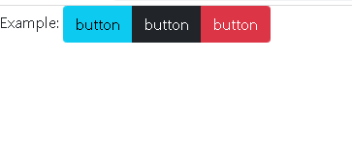

**Vertical Button Groups:** Bootstrap also supports vertical button groups stacked in a vertical manner rather than horizontal. Use the class “btn-group-vertical” to create a vertical button Vertical Button Groups: Bootstrap also supports vertical button groups stacked in a vertical manner rather than horizontal. Use the class “btn-group-vertical” to create a vertical button

**Example:**

<!DOCTYPE html>

<html lang="en">

<head>

<meta charset="UTF-8">

<meta http-equiv="X-UA-Compatible" content="IE=edge">

<meta name="viewport" content="width=device-width, initial-scale=1.0">

<title>Document</title>

<link rel="stylesheet" href="bootstrap-5.0.2-dist/css/bootstrap.min.css">

</script>

</head>

<body>

<div class="btn-group btn-group-lg">

<button type="button" class="btn btn-info">Click</button>

<button type="button" class="btn btn-light">Click</button>

<button type="button" class="btn btn-success">Click</button>

</div>

<div class="btn-group">

<button type="button" class="btn btn-primary">Click</button>

<button type="button" class="btn btn-info">Click</button>

<button type="button" class="btn btn-success">Click</button>

</div>

<div class="btn-group btn-group-sm">

<button type="button" class="btn btn-warning">Click</button>

<button type="button" class="btn btn-success">Click</button>

<button type="button" class="btn btn-danger">Click</button>

</div>

<div class="btn-group btn-group-xs">

<button type="button" class="btn btn-danger">Click</button>

<button type="button" class="btn btn-warning">Click</button>

<button type="button" class="btn btn-success">Click</button>

</div>

</body>

</html>

**Output:-**

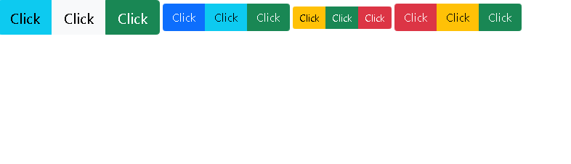

**7.How can you use Bootstrap to make thumbnails?**

[Bootstrap](https://www.geeksforgeeks.org/bootstrap-tutorials/)helps web developers to create thumbnails that are used to show linked images in grids with the pre-defined classes which help to reduce codes length. Thumbnails are created to provide a quick preview of images with small images.

**Thumbnail Image:**A thumbnail is a small image that represents a larger image. Bootstrap has an easy way to do this with thumbnails. Bootstrap’s *.thumbnail*class is used to show linked images in grids ([grid system](https://www.geeksforgeeks.org/bootstrap-4-grid-system/)), a thumbnail is created using class *.thumbnail* within the element [<a>](https://www.geeksforgeeks.org/html-a-tag/#:~:text=HTML%20Tag,-Difficulty%20Level%20%3A%20Basic&text=The%20tag%20(anchor,as%20its%20%E2%80%9Chref%E2%80%9D%20value.).  The class *.col-sm-\**and *.col-md-\** (where * represent number ), it is used to create grids of the images.

**Step by step guide for the implementation:**

**Step 1:** Include Bootstrap and jQuery CDN into the <head> tag before all other stylesheets to load our CSS.

*<link rel=”stylesheet” href=”http://maxcdn.bootstrapcdn.com/bootstrap/3.3.6/css/bootstrap.min.css”>   
<script src=”https://ajax.googleapis.com/ajax/libs/jquery/1.12.0/jquery.min.js”></script>   
<script src=”http://maxcdn.bootstrapcdn.com/bootstrap/3.3.6/js/bootstrap.min.js”></script>*

**Step 2:** Add [<div>](https://www.geeksforgeeks.org/div-tag-html/#:~:text=The%20div%20tag%20is%20used,%2C%20navigation%20bar%2C%20etc).&text=It%20is%20used%20to%20the,can%20be%20applied%20to%20them.) tag in the HTML body with class row. In that <div> create four *div*sections to create four images.

**Step 3:** Add “col-sm-6” and “col-md-3” to four *div* sections which creates webpage responsive.

**Step 4:** Add [<a>](https://www.geeksforgeeks.org/html-a-tag/) tag with class value *thumbnail*to define the link of the image in the next line.

<a href="#" class="thumbnail">

**Example:**

<!DOCTYPE html>

<html lang="en">

<head>

    <meta charset="UTF-8">

    <meta http-equiv="X-UA-Compatible" content="IE=edge">

    <meta name="viewport" content="width=device-width, initial-scale=1.0">

    <title>Document</title>

    <link rel="stylesheet" href="bootstrap-5.0.2-dist/css/bootstrap.min.css">

    </script>

</head>

<body>

    <h3 style="color: green">Bootstrap thumbnails</h3>

    <div class="row">

    <div class="col-sm-6 col-md-3">

        <a href="#" class="thumbnail">

        <img src="design_web_image_c1r1.webp"

            style="height: 100px; width: 100px"/>

        </a>

    </div>

    <div class="col-sm-6 col-md-3">

        <a href="#" class="thumbnail">

        <img src="design_web_image_c2r1.webp"

            style="height: 100px; width: 100px"/>

        </a>

    </div>

    <div class="col-sm-6 col-md-3">

        <a href="#" class="thumbnail">

        <img src="design_web_image_c2r2.webp"

            style="height: 100px; width: 100px"/>

        </a>

    </div>

    <div class="col-sm-6 col-md-3">

        <a href="#" class="thumbnail">

        <img src="design_web_image_c1r1.webp"

            style="height: 100px; width: 100px"/>

        </a>

    </div>

    </div>

</body>

</html>

**Outpot:**

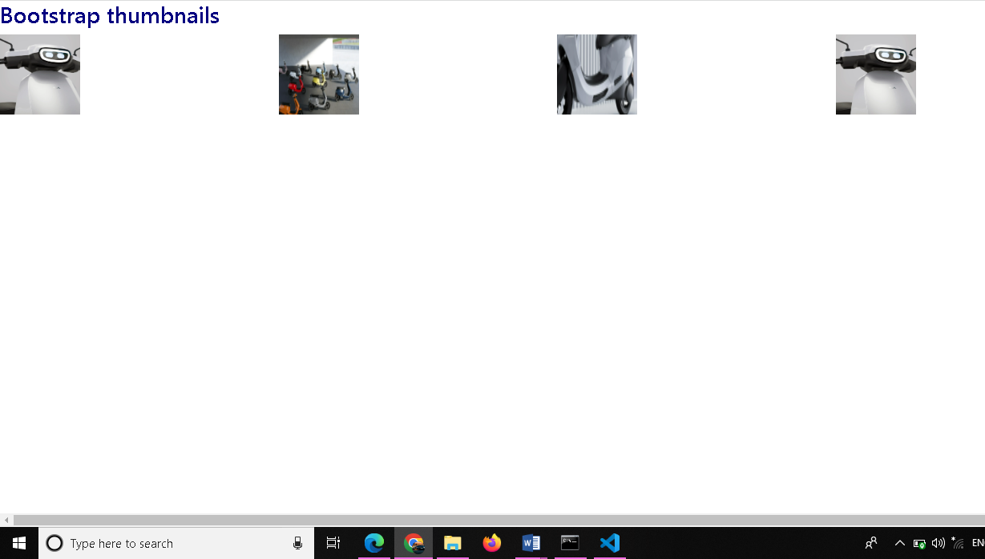

**Step 1:** We created div with class value as thumbnail and inserted image, after that add div with class .caption to define the description of the images <p>.

**Step 2:** Create buttons using <a> tag with class . btn .btn-success.

Example:

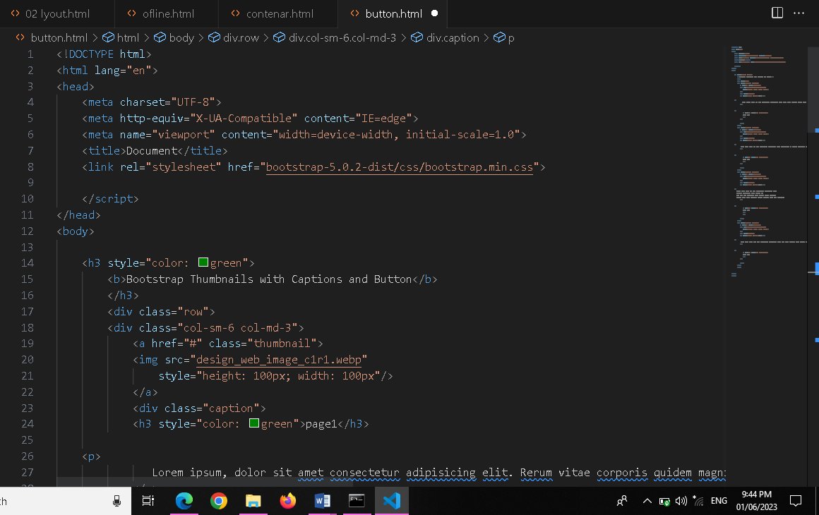

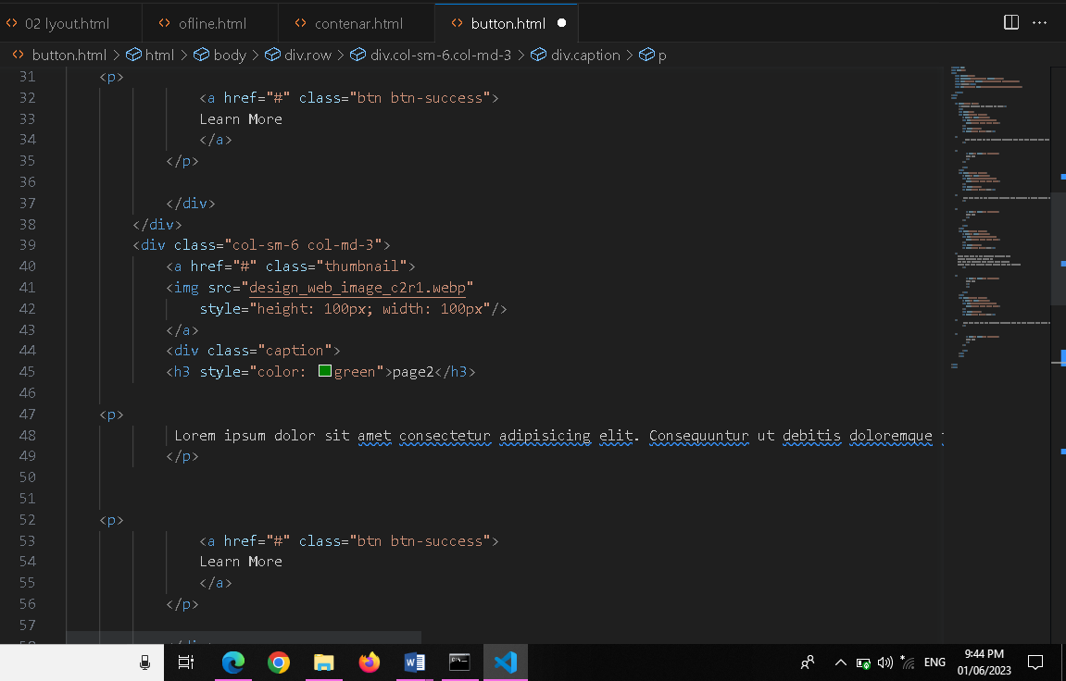

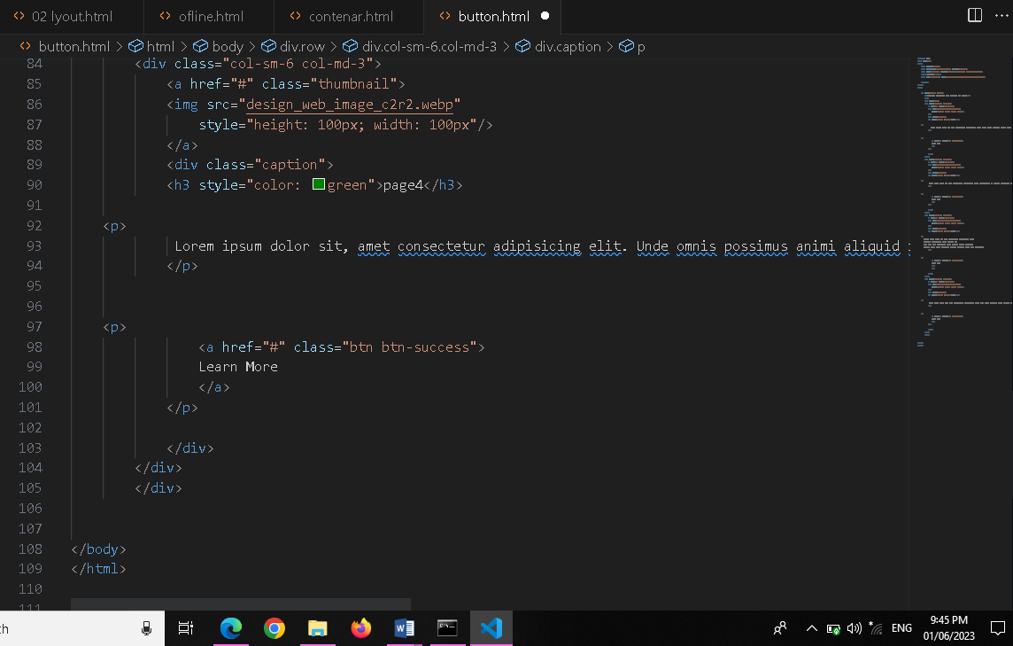

**Outpot:**

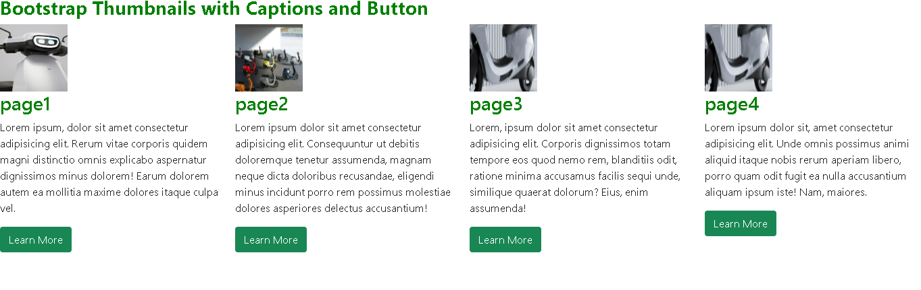

**8. In Bootstrap 4, what is flexbox?**

flex box is used to control the layout and alignment specification of Bootstrap 4 components. This box makes it easier to design flexible responsive layout structures without using float or positioning attributes.

Example:

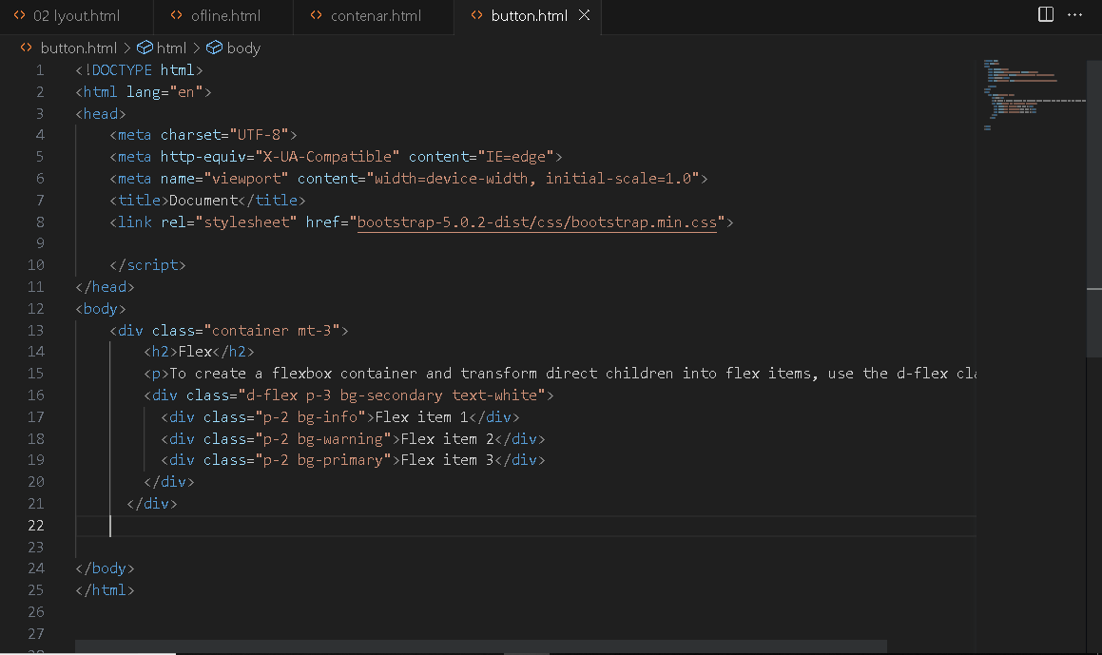

Outpot:

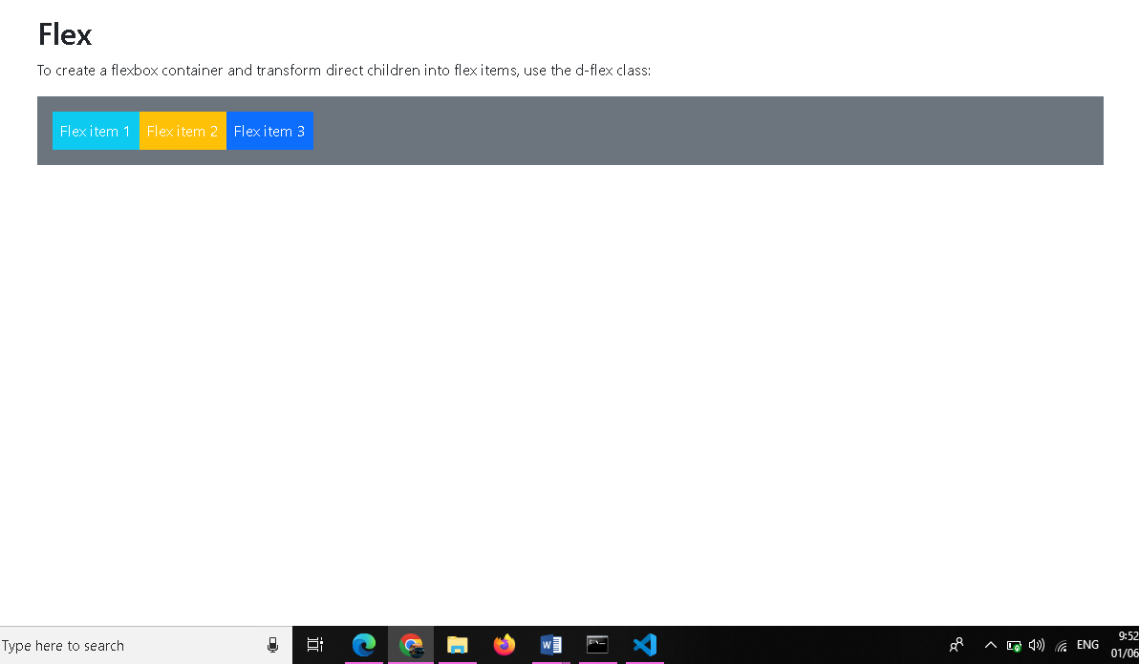

**9.How can one create an alert in Bootstrap?**

Approach: The .alert class followed by contextual classes are used to display the alert message on website. The alert classes are: .alert-success, .alert-info, .alert-warning, .alert-danger, .alert-primary, .alert-secondary, .alert-light and .alert-dark. We can use .alert-warning to create warning notification alerts in bootstrap.

Below is the procedure to implement a simple warning alert in Bootstrap

**Example:**

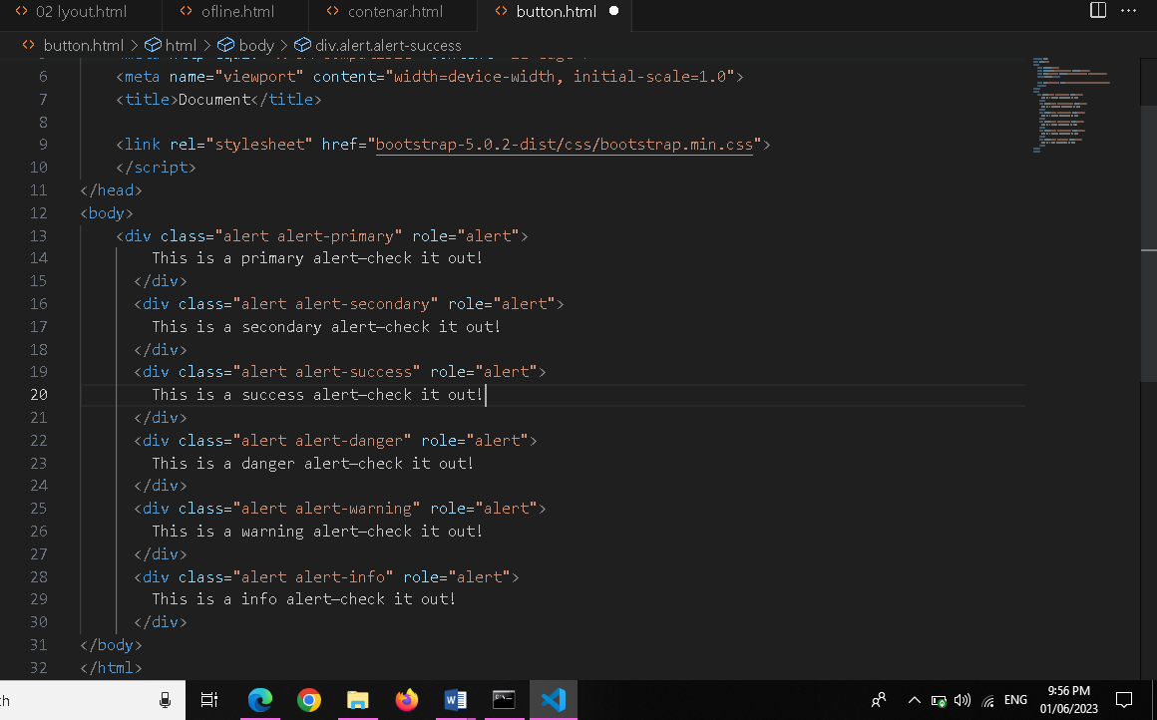

**Outpot:**

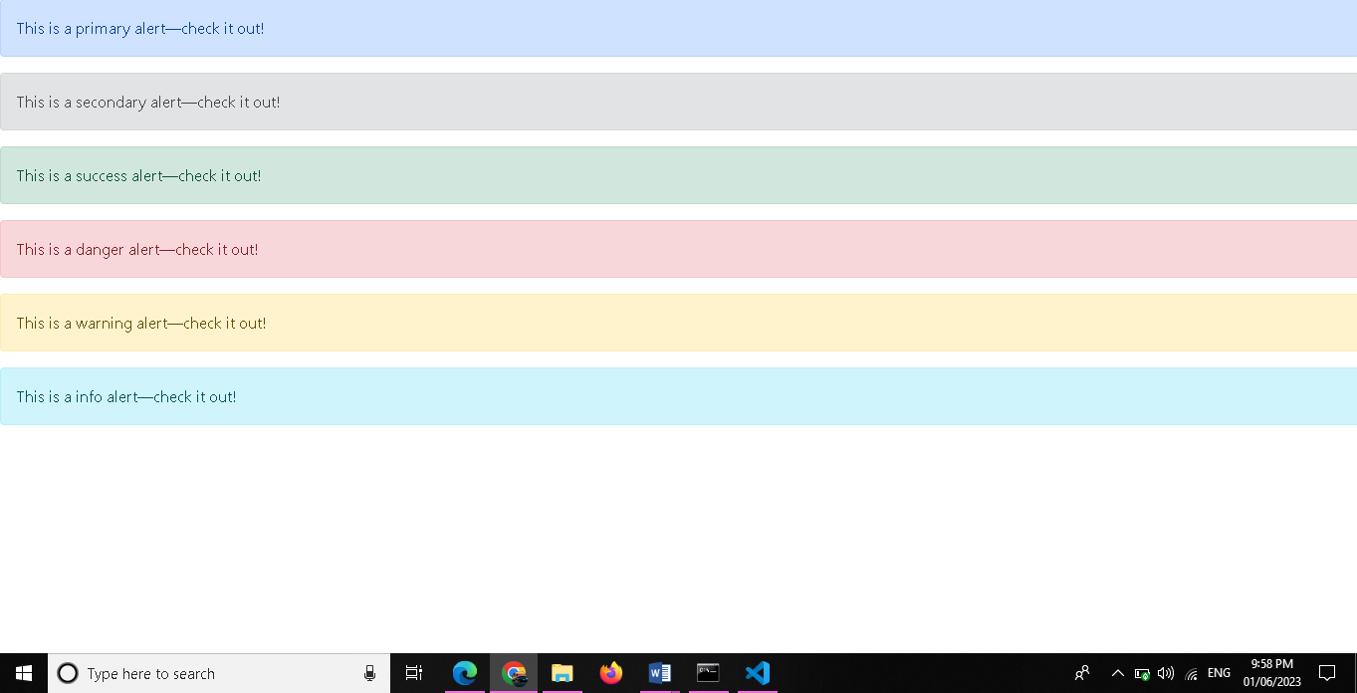

**10. What is a bootstrap card and how would you create one?**

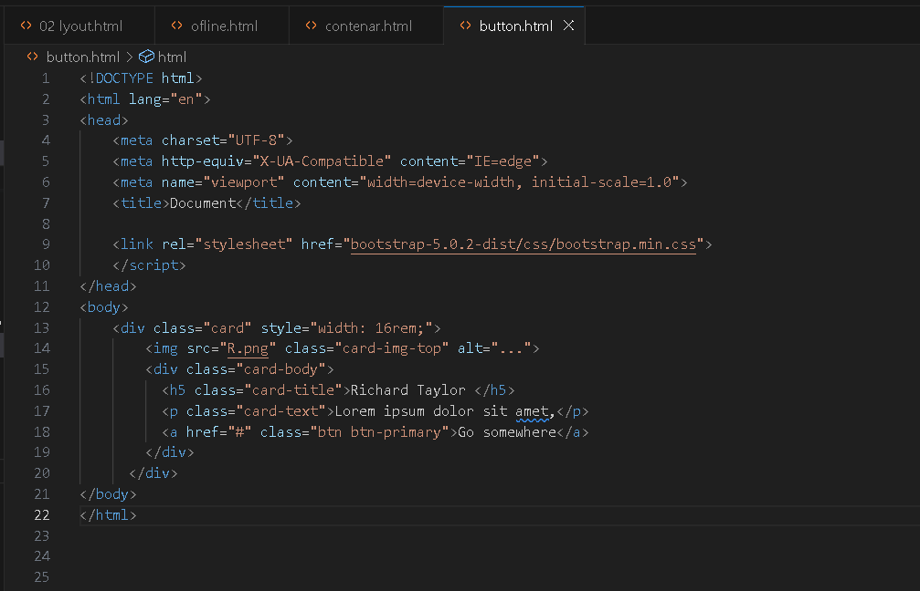

**Outpot:**

